# Data structure – representing objects

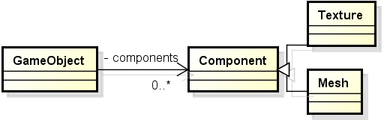Every object drawn onto the screen consists out of several components: Texture, Mesh, a matrix mapping the position and possibly more. Instead of creating separate variables for each of these components, the GameObject class has a single map named components. The key for each entry in the map is an enum naming what kind of Component the value is.

The Component class is nothing more than a header detailing we are dealing with components. It is not supposed to have any logic. All the logic will be placed in the classes that inherit from it, f or example the Mesh or the Texture.

GameObject has a method get(componentName) that will get the relevant component.